
INTERNSHIP REPORT
On
“Corona Vaccination Prediction”

A report submitted in partial fulfillment of the requirements for the Award of Degree of

Bachelor of Technology in Artificial Intelligence & Data Science
at
Dr. Babasaheb Ambedkar Technological University
Lonere, Raighad.

Submitted by
Sonavane Shashikant Madhukar
PRN No: 2221301995542
Class: Final B.Tech.
Roll No:59
Under the Guidance of
Prof. B. K. Mane

T.P.C.T.’S
College of Engineering, Osmanabad (Dharashiv)
Department of Artificial Intelligence & Data Science
Academic Year 2024-25 (Part-II) Semester VIII


Certificate
This is to certify that the Internship report on “Corona Vaccination Prediction” submitted by Sonavane Shashikant Madhukar (2221301995542 & 59) is the work done by him/her and submitted during the Academic Year 2024-25 (Part-II) Semester VIII, in partial fulfillment of the requirements for the award of the degree of Bachelor of Technology in Artificial Intelligence and Data Science at Dr. Babasaheb Ambedkar Technological University Lonere, Raighad.

Prof. B. K. Mane | Prof. S.V. Tekale
Guide | D.A.C
Prof. P.M. Pawar | Dr. V.V.Mane
HOD (AI&DS) | Principal

DECLARATION

I hereby declare that, I / We Mr./Ms. “Sonavane Shashikant Madhukar” is responsible for the work submitted in this project entitled " Corona Vaccination Prediction " that, the original work is my own except as specified in acknowledgments or in footnotes. To the best of my knowledge and belief, this project report contains no material previously published or written by another person, except where due reference is made and that neither the project report nor the original work contained herein has been submitted to this or any other institution for the award of any degree.

Date:- Sonavane Shashikant Madhukar

Place:- (2221301995542)

ACKNOWLEDGEMENT

There are to acknowledged and thank all the individuals who played defining role in shaping this project report. Without their constant support, guidance and assistance this report would not have been completed alone. I / We would personally thankful to my / our guide Prof. B. K. Mane ' for his expert guidance, continuous encouragement and ever willingness to spare time from his busy schedule for the project progress review. I / We am/ are also thankful to our Project coordinator. I / We express sincere thanks to Prof. P.M. Pawar, Head of Artificial Intelligence and Data Science Department for their valuable guidance, support and motivation. I / We am / are also thankful to Dr. V.V. Mane, Principal, TPCT's College of Engineering Dharashiv without whose support and encouragement, the work could not have been completed. I / We would like to thanks all Teaching and Non-teaching staff as well as the helping hands which directly or indirectly helped me during my project work. This work would have not been possible without their valuable help and motivation last but not the least my success and confidence lies solely on the blessing of my / our mother and my / our family.

Sonavane Shashikant Madhukar
(2221301995542)

Dr. BABASAHEB AMBEDKAR TECHNOLOGICAL UNIVERSITY,


LONERE, DIST: RAIGADH
.

T.P.C.T.’s

COLLEGE OF ENGINEERING,

DHAR
A
SHIV (OSMANABAD).

___________________________________________________________________________

CERTIFICATION OF COMPLETION
Of Industrial Training

This is to certify that Mr./Ms. Sonavane Shashikant Madhukar a student of Final Year B. Tech Enrolment No: 2221301995542, Is currently undergoing an Internship at Rubixe AI company.
The internship commenced on 10-March-2025 and is currently ongoing, as part of partial fulfilment towards the completion of the B.Tech Degree in Artificial Intelligence and Data Science under the discipline of T.P.C.T.’s College of Engineering, Dharashiv (Osmanabad).
We appreciate his contribution and dedication during the internship period so far.
Institute Code: 2130

Signature  Head of Department | Seal of Institute | Signature Principal

STICK THE INDUSTRY CERTIFICATE

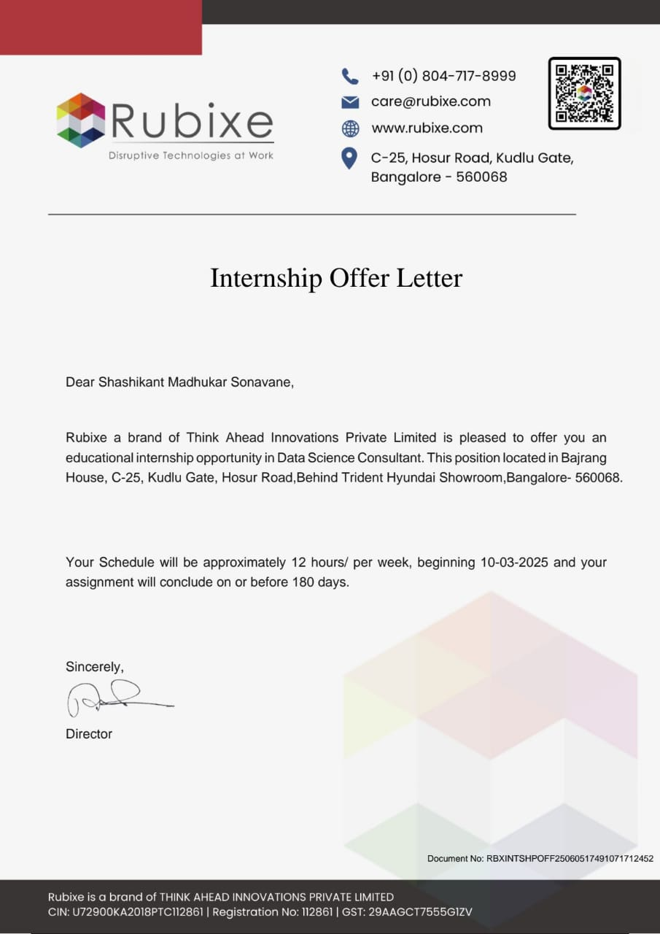

DIARY
FOR INTERNSHIP
Name of the Company: Rubixe AI Company
From: 10-March-2025 To 10-September-2025
Name of the Representative: S.Srinivas
Designation of the Representative: Associate Team Lead
Mobile No of the Representative: 9731442527
Name of the Student: SHASHIKANT MADHUKAR SONAVANE
Discipline: Artificial Intelligence and Data Science

Signature of the Student:

Signature of Industry representative:

Format 1 Company Profile
Collecting Information about Industry / Organization, available for training along with capacity: -
- Name of the Industry / Organization: Rubixe AI Company
- Address / communication details with email: Rubixe, HSR Layout, Bengaluru, Karnataka, India. Email- info@rubixe.com
- Contact person details:
    - Name: S.Srinivas
    - Designation: Associate Team Lead
    - Email: srinivas.s@datamites.com
    - Contact numbers: 9731442527
- Type of Product:
Service industry / Manufacturing Industry / Other : Artificial Intelligence Solutions and Consulting
- Type of Control:
Govt. / Semi Govt. / PSU / Pvt. / Prop. : PVT
- Type of Company:
Large Scale / Medium scale / Small scale : Medium scale
- Total no. of employees in the Industry / Organization: Approximately 450
- Details
  - Whether willing to offer Industrial training facility during May / June for Degree in Engineering students : Yes / No =Yes
  - If yes, whether you offer 6 weeks training : Yes / No III. Internship capacity possible:
Programme engg. group | Civil | Mech | CSE | ETC | AIDS | B  Pharmacy
Male |  |  | 1 |  | 2
Female |  |  |  |  | 1
Total |  |  | 1 |  | 3

Name & signature of Industrial Representative.

Format 2
Consent Letter from Parents / Guardians
To,
The principal,
College of engineering, Osmanabad.

Subject: Consent for Industrial Training.

Respected Sir,
I am fully aware that –
- My ward Sonavane Shashikant Madhukar studying in VIII semester at your institute has to undergo 24 weeks of internship for partial fulfillment towards completion of Internship.
- For this fulfilment he has been deputed at Rubixe AI Industry, located at Bengaluru, Karnataka for industrial training of 24 weeks for the period from 10/03/2025 to 10/09/2025 With respect to above, I give my consent for my ward to travel to & from the mentioned industry.
Further I undertake that-
  - My ward will be entirely under the discipline of the origination where he / she will be placed & will abide by rules & regulations in force, of the said organization.
  - My ward is not entitled to any leave during the raining period.
  - My ward will submit regularly, a prescribed weekly dairy, duly filly & countersigned by the training supervisor of the organization to the mentor faculty of the college.
  - My ward will undergo the training at his / her own cost & risks during training and / or stay.
I have explained the contents of the letter to my ward who has also promised to adhere strictly to the requirements. I assure that my ward will be properly instructed to take his own care to abide any accidents / injuries in the industry.

Date: Signature of Parent/ Guardian Place: Name:
Address:

Phone No.

Month 1: From 10-March-2025 to 10-April-2025

Expected work:
- Understand corona vaccination and dataset structure
- Review existing models and techniques
- Set up development environment
- Begin basic data exploration

Day | Activities carried out
Day | Activities carried out
1 | Introduced to vaccination prediction problem and objectives
2 | Collected relevant datasets (vaccination data, demographics, etc.)
3 | Studied dataset structure and target labels
4 | Set up Python, Jupyter, and required libraries
5 | Explored key features and noted data issues

The first week involved understanding the scope of the CORONA VACCINATION PREDICTION project and its objectives.
Reviewed the dataset structure, key features, and began exploring data patterns.
Set up the development environment and initiated basic data cleaning.

Signature of the student Signature of the industry supervisor

Month 2: From10-April-2025 to 10-May-2025

Expected work:

- Detailed EDA and visualization
- Feature extraction and transformation
- Handle missing values and encode categories
- Prepare dataset for modeling

Day | Activities carried out
1 | Analyzed data distribution and feature relationships
2 | Created plots to understand vaccination trends and age groups
3 | Encoded categorical features (gender, region, etc.)
4 | Handled missing values using statistical imputation
5 | Scaled numeric features and normalized data
6 | Completed data transformation and feature selection

The second month focused on detailed exploratory data analysis to uncover trends in pricing.
Handled missing values, encoded categorical features like Airline and Source, and treated outliers.
Completed initial feature engineering to prepare the dataset for modeling.

Signature of the student Signature of the industry supervisor

Month 3: From10-May-2025 to 10-June-2025

Expected work:
- Model training and evaluation
- Regression models experimentation
- Hyperparameter tuning
- Select best-performing model

Day | Activities carried out
1 | Trained classification models (Logistic Regression, Decision Tree)
2 | Tested ensemble methods (Random Forest, XGBoost)
3 | Evaluated using accuracy, precision, recall, and AUC
4 | Applied k-fold cross-validation for model validation
5 | Tuned hyperparameters with GridSearchCV
6 | Selected and saved final model using joblib

Trained multiple machine learning models including Random Forest and XGBoost for price prediction.
Evaluated model performance using MAE, RMSE, and R² score metrics.
Applied cross-validation and selected the best-performing model for final integration.

Signature of the student Signature of the industry supervisor

Month 4: From 10-June-2025 to 10-July-2025

Expected work:
- Integrate model into Python/Jupyter
- Build reusable prediction logic
- Simulate predictions with custom input
- Prepare code for Django integration

Day | Activities carried out
1 | Validated final dataset integrity
2 | Loaded trained model in Jupyter and simulated predictions
3 | Created functions for preprocessing and prediction
4 | Ensured input format consistency with user data
5 | Handled data scaling and label transformation in functions
6 | Prepared notebook for transition to Django backend

Focused on model optimization and refining the dataset for better accuracy.
Applied scaling, transformations, and handled class imbalance where needed.
Finalized a clean and structured dataset ready for reliable model training.

Signature of the student Signature of the industry supervisor

